Source:<https://www.fda.gov/medical-devices/device-advice-comprehensive-regulatory-assistance/overview-device-regulation> & <https://www.accessdata.fda.gov/scripts/cdrh/cfdocs/cfpcd/classification.cfm?id=BRZ>

* Another blood giving set was labeled as class 2 - good to assume same for us
* A 510(k) is a premarket submission made to FDA to demonstrate that the device to be marketed is as safe and effective, that is, substantially equivalent, to a legally marketed device (section 513(i)(1)(A) FD&C Act). Submitters must compare their device to one or more similar legally marketed devices and make and support their substantial equivalence claims

Source: <https://pmc.ncbi.nlm.nih.gov/articles/PMC8087432/#:~:text=3.,regulated%20according%20to%20stringent%20controls.&text=A%20stethoscope%2C%20for%20example%2C%20poses,of%20in%20vitro%20diagnostic%20devices>.

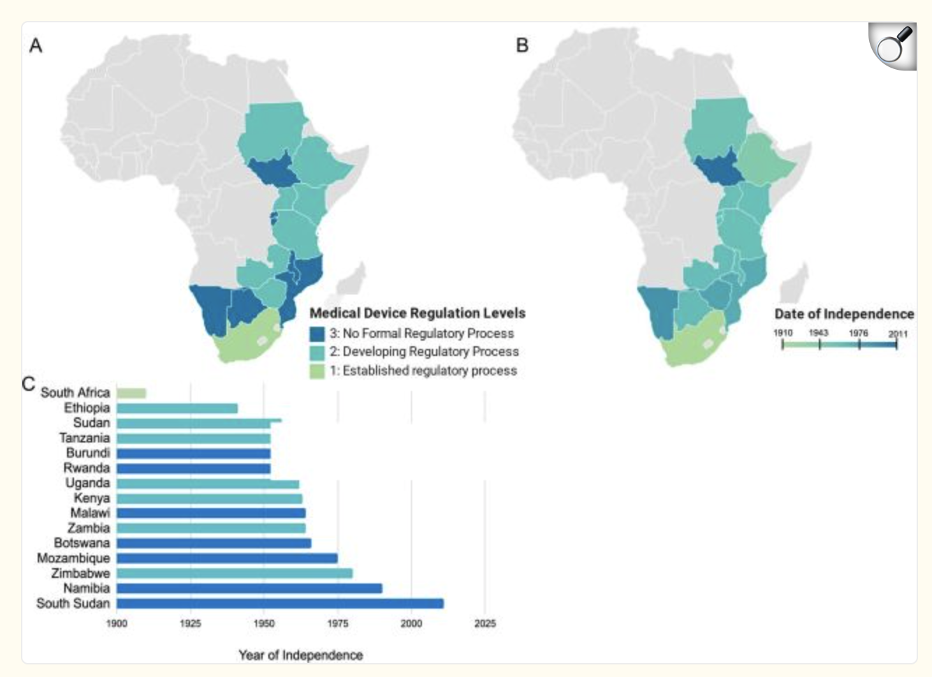

* Pretty sure no regulations - as of 2021
* All COSECSA member countries and South Africa with the exception of Burundi,[21](https://pmc.ncbi.nlm.nih.gov/articles/PMC8087432/#B21) Malawi,[22](https://pmc.ncbi.nlm.nih.gov/articles/PMC8087432/#B22) and Mozambique[23](https://pmc.ncbi.nlm.nih.gov/articles/PMC8087432/#B23) have legislation mandating the regulation of medical devices
* Just follow FDA standardas

Source: <https://clinregs.niaid.nih.gov/country/malawi/tanzania>

* General Facts
  + No clinical trial registration required
  + In-country sponsor presence/representation required
    - Dr. Anne
* Regulatory authority
  + Clinical research overseen by Pharmacy and Medicines Regulatory Authority (PMRA) and National Commission for Science and Technology (NCST)
* National Commission for Science and Tech
  + NCST appraises, reviews, monitors, and evaluates priority research and development programs, plans, and projects of research and development institutions.
  + The NCST also encourages the use of local expertise in science and technology matters via a set of professional standards, ethics, and guidelines.
  + NCST-issued license is required for research activities involving humans; research involving clinical trials; research activities of multicentered research; the collection, storage and use of human samples for research; the accreditation of research institutions; and the establishment of an institutional research ethics committee (EC)
  + Contact info
    - Mailing Address:  
      National Commission for Science and Technology  
      1st Floor Lingadzi House, Robert Mugabe Crescent  
      Private Bag B303  
      Lilongwe 3, Malawi
    - Phone: +265 1 771 550  
      Email: [infor@ncst.mw](mailto:infor@ncst.mw)

Source: <https://www.pmra.mw/product-registration/>

* Product Registration
  + Submit dossiers to office of Director General
    - accepts dossiers which are in common technical document (CTD) format as per ICH M4Q or WHO TRS 970 annex 4. This application requires completion of PMRA new product registration form (8A)
  + There are three ways of submission of product registration namely,
    - routine procedure where full assessment is done by PMRA assessors;
    - WHO Collaborative Registration Procedure for products which are WHO prequalified;
    - ZAZIBONA collaborative registration procedure where SADC countries jointly share and discuss dossier assessment report

Source: <https://clinregs.niaid.nih.gov/country/malawi#scope_of_assessment>